**VISVESVARAYA TECHNOLOGICAL UNIVERSITY**

**“JNANA SANGAMA” Belagavi, Karnataka- 590 018**



2023-2024

A Mini Project Report

On

**“Estimation of thrust calculation using Afterburner”**

***Submitted in partial fulfillment of the requirement for the award of the degree of***

**“Bachelor of Engineering in**

**Aeronautical Engineering”**

***Submitted By***

**SUDEEP[1AY21AE041]**

**M VISHWARADHYA[1AY2AE403]**

**MOHAMMED MAAZ[1AY22AE404]**

**KUMAR V[1AY22AE400]**

**Under the Guidance of**

**Amar Gandge**

**Assistant professor Department of Aeronautical Engineering**



# DEPARTMENT OF AERONAUTICAL ENGINEERING ACHARYA INSTITUTES OF TECHNOLOGY,

**Sol Devanahalli, Hesaraghatta Road, Bangalore-560107**

# Acharya Institutes of Technology,

**Sol Devanahalli, Hesaraghatta Road, Bangalore-560107**

## DEPARTMENT OF AERONAUTICAL ENGINEERING



# CERTIFICATE

This is to certify that the dissertation work entitled “**AFTERBURNER**” is a bonified work carried out by Mr. Sudeep M, 1AY21AE041, Mr. **M Vishwaradhya, 1AY22AE403, Mr. Mohammed Maaz, 1AY22AE404,** Mr. **Akash Kumar V, 1Ay22AE400** in partial fulfillment of award of the degree of **Bachelor of Engineering in Aeronautical Engineering**, from the **Visvesvaraya Technological University, Belagavi** during the year **2023-2024**. It is certified that all corrections/suggestions indicated for Internal Assessment have been incorporated in the report deposited in the departmental library. The project report has been approved as it satisfies the academic requirements in respect of Project work prescribed for the said Degree.

|  |  |
| --- | --- |
| ___________________    Signature of Coordinator  **Mr. Amargandge**  **Asst.professor**  Dept. of Aeronautical  Engineering  AIT, Bangalore | ___________________  Signature of HOD  **Dr.**  HOD  Dept. of Aeronautical  Engineering  AIT, Bangalore |
|  |

___________________

Signature of Principal

**Dr. Rajath Hegde**

AIT, Bangalore

**Name of the Examiner Signature**

1. ____________________ 1. ________________
2. ____________________ 2. ________________

## 

## ACHARYA INSTITUTES OF TECHNOLOGY

Sol Devanahalli, Hesaraghatta Road, Bangalore-560107

### DEPARTMENT OF AERONAUTICAL ENGINEERING



# DECLARATION

We, **Sudeep M**, **M Vishwaradhya, Mohammed Maaz, Akash Kumar V**, the student of final semester of Aeronautical Engineering, Acharya Institutes Of Technology, Bangalore – 560107, declare that the work entitled **“AFTERBURNER”** has been successfully completed under the guidance of Asst. professor **Amar Gandge**, Acharya Institutes Of Technology, Department of Aeronautical Engineering, Bangalore. This dissertation work is submitted to Visvesvaraya Technological

University in partial fulfillment of the requirements for the award of degree of Bachelor of Engineering in Aeronautical Engineering during the academic year 2023 - 2024. Further the matter embodied in the project report has not been submitted previously by anybody for the award of any degree or diploma to any university.

Place: Bengaluru Sudeep M[1AY22AE041]

Akash Kumar v [1AY22AE400]

M Vishwaradhya[1AY22AE403]

Mohammad Maaz[1AY22AE404

ACKNOWLEDGEMENT

It is my proud privilege and duty to acknowledge the kind of help and guidance received from several people in preparation of this report. It would not have been possible to prepare this report in this form without their valuable help, cooperation and guidance.

First and foremost, I wish to record my sincere gratitude to the **Management of Acharaya institutes of technology** and to our beloved Principal, **Dr Rajath Hegde**, Acharya institutes of technology, Bangalore for his constant support and encouragement in preparation of this report and for making available library and laboratory facilities needed to prepare this report.

My sincere thanks to **Dr.,** Associate Professor and Head, Department of Aeronautical Engineering, AIT, for his valuable guidance and allowing us to conduct investigations for this project. The numerous discussions with him were extremely helpful. I hold him in esteem for guidance, encouragement and inspiration received from him.

My sincere thanks to **Amar Gandge**, Asst.Professor, Department of Aeronautical Engineering, AIT, for his valuable suggestions and guiding me in investigations for this project. The numerous discussions with him were extremely helpful.

I hold him in esteem for guidance, encouragement and inspiration received from him.

My sincere thanks to all professors for supporting the work related to this project.

Their contributions and technical support in preparing this report are greatly acknowledged.

Finally, I thank my family, friends and all those who always encouraged me and helped me in all the possible ways for my studies. I wish to thank my parents for financing my studies in this college as well as for constantly encouraging me to pursue engineering.

My parent’s personal sacrifice in providing this opportunity to pursue engineering is greatly acknowledged.

**Sudeep M [1AY21AE041]**

**M Vishwaradhya[1AY22AE403]**

**Mohammed Maaz[1AY22AE404]**

**Akash Kumar V[1AY22AE400]**

### Abstract

The afterburner, also known as a reheat, is a component of a jet engine designed to increase thrust output beyond that achievable by the core engine alone. This device is commonly used in military and supersonic aircraft to achieve higher speeds and improved performance. The afterburner operates by injecting additional fuel into the jet pipe, downstream of the engine's turbine, and igniting it to burn in the high-temperature, high-pressure exhaust gases. This process significantly boosts thrust by expanding the exhaust gases and increasing their velocity.

Afterburners are characterized by their ability to provide a substantial thrust increase, often up to 50% over the engine's maximum dry thrust, although this comes with a trade-off in fuel efficiency. The operation of an afterburner involves complex thermal dynamics and combustion processes, which can lead to higher operational temperatures and increased noise levels. These factors are carefully managed to balance performance with the durability of engine components.

The use of afterburners is particularly advantageous in applications requiring rapid acceleration and high-speed performance, such as in supersonic flight and combat scenarios. However, their inefficiency in fuel consumption limits their use in commercial aviation, where efficiency and environmental considerations are paramount.

Contents

1. **INTRODUCTION…………………………………………………………. 09** 
   1. **Definition of electric propulsion……………………………………….. 09**
   2. **About drive cycle……………………………………………………….. 09** 
      1. **Global importance………………………………………………… 10**
      2. **Examples regarding electro-chemical propulsion engine………. 11**
      3. **Divisions of drive cycle……………………………………………. 11**
   3. **Literature regarding electro-chemical propulsion engine…………… 13**
2. **METHODOLOGY………………………………………………………... 14** 
   1. **Basic methodology……………………………………………………… 14**
   2. **Types of Electrochemical Engines…………………………………….. 14** 
      1. **Applications………………………………………………………... 15**
3. **DESIGN & FABRICATION PROCESS………………………………… 16** 
   1. **Design Process…………………………………………………………... 16**
   2. **Fabrication Process……………………………………………………... 17**
4. **ADVANTAGES, DISADVANTAGES AND APPLICATIONS………… 19** 
   1. **Advantages of Electrochemical Propulsion Engines………………….. 19**
   2. **Disadvantages of Electrochemical Propulsion Engines………………. 19**
   3. **Applications of Electrochemical Propulsion Engines………………… 20**
5. **RESULTS AND DISCUSSION…………………………………………... 22** 
   1. **Results………………………………………………………………….... 22** 
      1. **Performance Metrics……………………………………………… 22**
      2. **Operational Consideration……………………………………….. 22**
   2. **Discussion Points………………………………………………………... 23**
6. **CONCLUSION & FUTURE WORK……………………………………. 24** 
   1. **Conclusion………………………………………………………………. 24**
   2. **Future work……………………………………………………………... 25**
7. **REFERENCES…………………………………………………………….. 27**

**List Of Figure**

**Figure 1.1 Afterburner**

**Figure 3.1 CAAD design**

**Figure 1.2 The NEDC of Afterburner**

**Figure 3.2 Model Image**

List of Tables

Table 2.1: Material used.

Table 2.2: Model dimensions.

Table 5.1: Result calculation.

CHAPTER 1

#### 1.Introduction

1.1. Definition of electric propulsion

A hybrid electric aircraft (HEA) uses a combination of traditional fossil fuel-powered engines and electric motors to provide propulsion. HEAs typically use electric motors for take-off and landing, while conventional engines give power while in the air.

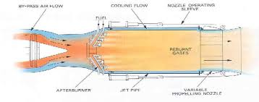

Figure 1.1: Afterburner.

1.2. About drive cycle

Drive cycles are standardized speed vs. time data profiles used by automotive manufacturers, testers, and researchers for fuel consumption, emissions, and durability testing and validation. Over the years, they have changed from being used solely for emissions and dynamometer testing in internal combustion engine (ICE) applications to also acting as inputs for vehicle simulations, parameterizing, and powertrain component sizing. In a review paper published in 2002 by Esteves-Booth et al., it mentioned simulation and estimation capabilities of certain drive cycles, and how drive cycles provide more than just emissions testing. This paper was over two decades ago, when drive cycles were starting to become more popular for simulations rather than solely for emissions testing. Over the past decade, battery electric- and fuel cell-powered vehicles have initially attracted more interest and increasingly a higher market share due to a range of legislative and environmental factors. These vehicles have the potential to reduce and, indeed, remove, combustion emissions, including CO2 and NOx, resulting in improved air quality and mitigated environmental impact from personal transportation. When studying the performance of these vehicles or energy sources, drive cycles are a crucial tool to simulate realistic driving. These cycles are used by systems designers and researchers for activities as diverse as cell-level degradation studies to pack-level component sizing.

Figure 1.2:

The NEDC The afterburner, also known as a reheat, is a component of a jet engine designed to increase thrust output beyond that achievable by the core engine alone. This device is commonly used in military and supersonic aircraft to achieve higher speeds and improved performance. The afterburner operates by injecting additional fuel into the jet pipe, downstream of the engine's turbine, and igniting it to burn in the high-temperature, high-pressure exhaust gases. This process significantly boosts thrust by expanding the exhaust gases and increasing their velocity.

Afterburners are characterized by their ability to provide a substantial thrust increase, often up to 50% over the engine's maximum dry thrust, although this comes with a trade-off in fuel efficiency. The operation of an afterburner involves complex thermal dynamics and combustion processes, which can lead to higher operational temperatures and increased noise levels. These factors are carefully managed to balance performance with the durability of engine components.

The use of afterburners is particularly advantageous in applications requiring rapid acceleration and high-speed performance, such as in supersonic flight and combat scenarios. However, their inefficiency in fuel consumption limits their use in commercial aviation, where efficiency and environmental considerations are paramount. The development of advanced afterburner technologies continues to focus on optimizing thrust output while mitigating fuel consumption and emissions.drive cycle.

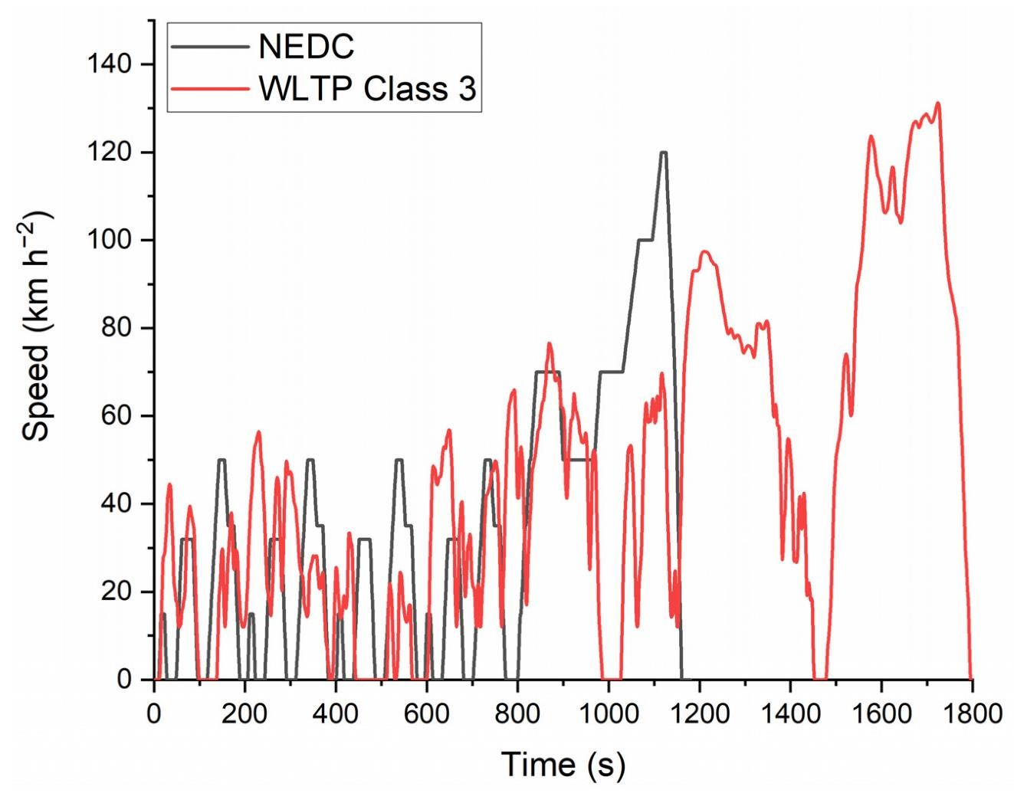

##### 1.2.1. Global importance

No global standard exists for drive cycles, although certain drive cycles, such as the Worldwide Harmonized Light Vehicles Test Procedure (WLTP) and Federal Test Procedure (FTP), are extensively employed and becoming mandated to be used by automotive manufacturers upon the release of a new vehicle. Some countries and regions have also implemented their own specific legislative drive cycles, such as The New European Drive Cycle (NEDC) or China Automotive Test Cycle (CATC), while others use a jointly produced worldwide drive cycle . However, all drive cycles have their limitations and are not universally applicable across different vehicle powertrain architectures (ICE, EV, and hybrid), vehicle size classifications, and natures of application. Other limitations have been identified, including not accurately representing real-world driving behaviors, which can include significant differences in energy usage between drive cycles using similar dynamics, locations having different driving dynamics than others, and region-specific driving styles and needs.

##### 1.2.2. Examples regarding electro-chemical propulsion engine

For example, Son et al. conducted a driving comparison study between driving in the United Kingdom (UK) and South Korea using a combustion-powered vehicle (CV). The driving survey was conducted based on similar road conditions in the UK and North Korea, with the UK being slightly higher in driving distance. It was found that the vehicles driven in the UK have resulted in a much higher fuel economy; the vehicle used in the UK had a fuel efficiency of 19.52 km L−1, while the vehicle used in South Korea had a fuel efficiency of 8.66 km L−1. This was due to different driver characteristics, road environments, and traffic flow between the two regions. This suggests that if a UK-based drive cycle were to be used to design and estimate the range of a vehicle for the South Korean market, the result would be skewed.

1.2.3. Divisions of drive cycle

Drive cycles can be divided into two categories: modal and transient. Transient drive cycles are usually collected based on real driving data while modal cycles are not. This categorization will be further explained in. The introduction of drive cycles in different regions of the world has evolved as summarized in. In Japan, the first-ever legislative drive cycle, 4-Mode, was introduced in 1966. Thirty-nine years later, this was superseded by the JC08 cycle in 2005. In the United States, the California 7-Mode drive cycle was established in 1968. The latter cycle was created based on Los Angles Street conditions and was used as a national drive cycle. The EPA Federal Test Procedure drive cycle was introduced as a legislative test procedure for passenger cars in 1972, hence the naming classification (FTP-72). FTP-72 later became FTP-75 in 1975. These two cycles were established with the aim of streamlining the implementation of the 1978 gas guzzler tax, which serves as a deterrent for manufacturing vehicles with a low fuel efficiency. In 1970, European countries started with a legislative modal cycle, UN-ECE Regulation Number 15 (ECE15), which later became a part of the New European Drive Cycle (NEDC); this was later replaced by a cycle known as the Worldwide Harmonized Light Vehicle Test Procedure (WLTP) cycle in 2017 . In 2019, China introduced its transient drive cycle, China Automotive Test Cycles (CATC), to reflect the country’s unique driving dynamics due to extreme congestion resulting from overpopulation. A detailed historical discussion of these drive cycles is covered in. None of the drive cycles in the timeline was built purely for electric vehicles, but as ‘general use’ cycles. The electric motor is a major component that makes electric vehicles different from CV driving. Electric vehicles have instant torque from a standstill and produce a speed and acceleration curve different from those of CVs, which should be represented in a drive cycle. Protocols already exist in converting conventional-use drive cycles for electrochemical bench testing; for example, Fuel Cell and Hydrogen Joint Undertaking (FCH) has a current control-based NEDC drive cycle for fuel cell bench testing. However, NEDC was a modal drive cycle introduced earlier in the 1980s, when electrochemical vehicles were far less utilized and researched compared to today. In addition, NEDC was not collected from real-life driving data; instead, it was a dynamometer testing cycle better suited for emissions testing rather than vehicle engineering or simulation. Using a transient drive cycle that mimics real-life driving scenarios and actual vehicle behavior is crucial for the proper design and accurate range estimation of electrochemical vehicles, which is covered in. Jeong et al. simulated electric vehicle driving based on conventional drive cycles and concluded that the cycles do not account for the higher acceleration capabilities of electric vehicles. In addition, the importance of developing ‘electric-only’ drive cycles were emphasized. An electric vehicle transient drive cycle can be collected using techniques such as the micro-trip clustering technique combined with a CANBUS datalogger. Some electric drive cycle collections have been done in the past, such as in a study conducted by Peng et al. for developing a hybrid electric bus cycle in Zhengzhou, China using the Markov chain method. However, none are legislated for widespread use and tend to be city, research facility, or academic institution dependent. The lack of electric drive cycles is a legislative problem rather than an engineering problem, as collecting one is straightforward but requires organization, data acquisition, and manpower. As we enter the age of electrochemical propulsion, legislated and dedicated region-specific electric vehicle drive cycles are crucial for the accurate representation of these vehicles.

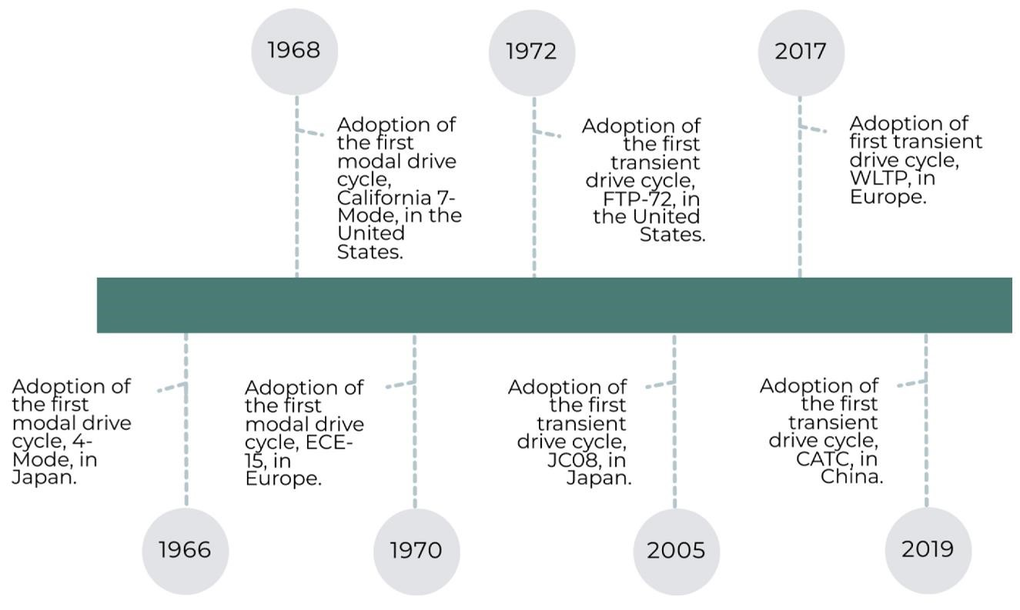

Figure 1.3: Timeline of modal and transient drive cycle adoption between different countries.

1.3. Literature regarding electro-chemical propulsion engine

There have been review papers regarding drive cycles in the previous literature, but very few recent ones; none have gone into depth about the history of the cycles and their adaptability to electrochemical vehicles of the current decade. Esteves-Booth et al. published a review paper in 2002, which reviewed developments in drive cycles and broke them down into emission factor, speed, and modal models. Emission factor models only correspond to one type of vehicle and driving route and are not representative of other types of vehicles, such as electrochemical vehicles. Average speed models rely on emission functions and are mainly used for emissions testing instead of vehicle or device simulations. Modal cycles are described in the paper as the most realistic compared to real-world driving.

### CHAPTER 2

#### 2.Methodology

2.1. Basic methodology

Electrochemical propulsion engines, often used in spacecraft and satellites, utilize electrochemical reactions to generate thrust. Here's a basic methodology of how such engines typically work:

1. Electrolyte and Electrodes: The engine consists of an electrolyte (often a liquid or gel) and two electrodes (anode and cathode). These electrodes are made from materials that can undergo oxidation and reduction reactions.
2. Electrochemical Reactions: When an electric current is passed through the electrolyte, electrochemical reactions occur at the electrodes. At the anode, oxidation reactions take place, generating ions or releasing electrons. At the cathode, reduction reactions occur, where ions gain electrons.
3. Ion Generation: As a result of these reactions, positively charged ions (cations) are generated at the anode and negatively charged ions (anions) at the cathode.
4. Electrostatic Acceleration: An electric field is applied across the engine, created by the potential difference between the electrodes. This field accelerates the ions away from the electrodes.
5. Thrust Generation: The accelerated ions are expelled from the engine at high velocity through a nozzle or grid, creating a thrust force according to Newton's third law of motion (action and reaction).
6. Specific Impulse: The performance of the engine is characterized by its specific impulse (Isp), which measures the efficiency of the propulsion system. Specific impulse is typically higher for electrochemical engines compared to traditional chemical rockets, making them advantageous for long-duration space missions.

2.2.Types of Electrochemical Engines:

* Ion Thrusters: Use electrostatic acceleration to expel ions.
* Hall Effect Thrusters: Utilize a magnetic field to control the movement of ions.
* Electrochemical Capacitors: Store electrical energy for rapid discharge, useful for short bursts of thrust.

2.2.1. Applications:

Electrochemical propulsion engines are commonly used in satellites and deep-space missions where precision, efficiency, and longevity are crucial. They are valued for their ability to operate over long durations with minimal fuel consumption compared to chemical propulsion systems.

Overall, electrochemical propulsion engines represent a sophisticated integration of chemistry, electricity, and physics to achieve controlled propulsion in the vacuum of space.

|  |  |
| --- | --- |
| GI Sheet thickness | 0.8mm |
| Butane gas | 250ml |
| Battery for propeller | 2200mah |
| Servo controller |  |
| Servo regulator |  |
| EDF Servo motors |  |
| Propeller diameter | 6inch |
| Gas regulator inlet diameter | 4mm |
| Fuel line diameter | 2mm |

Table 2.1: Material used

|  |  |
| --- | --- |
| Inlet diameter | 8inch |
| Inlet exhaust diameter | 5inch |
| Combustion inlet diameter | 5inch |
| Combustion exhaust diameter | 5inch |
| Nozzle inlet diameter | 5inch |
| Nozzle exhaust diameter | 2.5inch |

Table 2.2: Model dimensions

### CHAPTER 3

#### 3.Design & Fabrication Process

Designing and fabricating an afterburner involves several key steps and considerations. Here’s an outline of the process:

3.1. Design Process

1. Mission Requirements Analysis: - Determine the specific mission requirements such as thrust magnitude, specific impulse (efficiency), duration of operation, and environmental conditions (e.g., vacuum of space).

- Define constraints such as mass, volume, and power availability.

2. System Architecture Design: - Define the overall architecture of the propulsion system, including the arrangement of electrodes, electrolyte containment, ion acceleration mechanism (nozzle or grid), and power management subsystems.

- Select the type of electrochemical propulsion technology (e.g., ion thruster, Hall effect thruster) based on mission requirements and available technology.

3. Electrolyte and Electrode Selection: - Choose an appropriate electrolyte that matches the mission parameters (liquid, gel, solid-state).

- Select electrode materials that are compatible with the electrolyte and capable of withstanding electrochemical reactions over extended periods.

4. Electric Field Generation: - Design the system for generating and controlling the electric field required to accelerate ions.

- Specify power requirements and integration with power supply systems.

1. Thermal Management: - Develop strategies for managing heat generated during electrochemical reactions to maintain operational efficiency and prevent thermal damage.
2. Structural Design and Material Selection: - Design the physical structure of the engine components, considering factors such as weight, mechanical stability, and integration with spacecraft systems.

- Choose materials that are lightweight, durable, and compatible with space environment conditions (e.g., vacuum, radiation).

7. Integration with Spacecraft: - Ensure compatibility and integration with the spacecraft platform, including mounting, structural interfaces, and electrical connections.

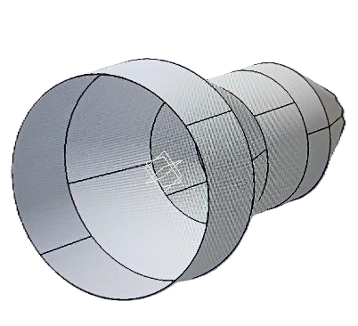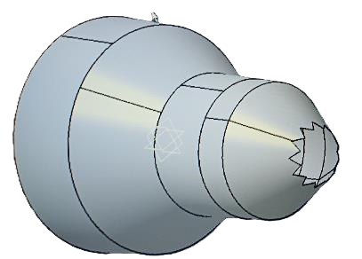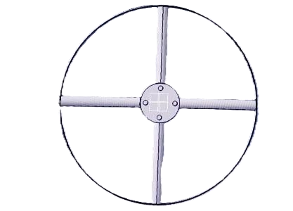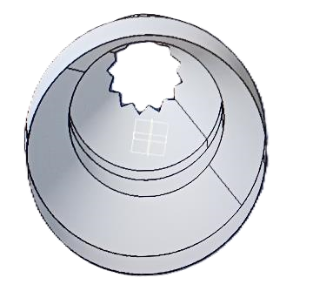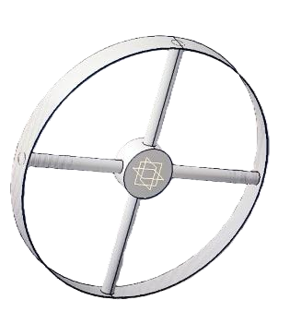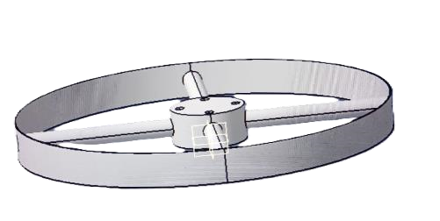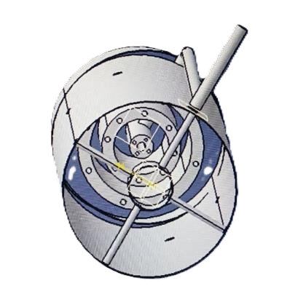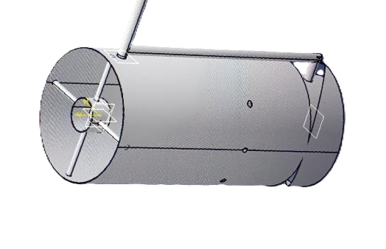

Figure 3.1: CAAD diagram of the model.

3.2. Fabrication Process

1. Component Fabrication: - Fabricate electrodes using suitable manufacturing techniques such as machining, deposition, or additive manufacturing (3D printing).

- Construct electrolyte containment structures and other engine components.

2. Assembly: - Assemble electrodes, electrolyte containers, and other components into the propulsion engine assembly.

- Integrate electrical wiring and connectors.

3. Testing and Validation: - Conduct initial component testing for functionality, including electrical conductivity, chemical compatibility, and mechanical integrity.

- Perform system integration tests to verify overall performance and compatibility with spacecraft systems.

1. Performance Optimization: - Iteratively test and optimize system parameters such as voltage levels, current flow, and electrolyte composition to achieve desired thrust and efficiency.
2. Quality Assurance: - Implement quality control measures throughout the fabrication process to ensure reliability and performance consistency.

- Conduct environmental testing (e.g., thermal vacuum testing) to simulate space conditions and verify operational reliability.

6. Documentation and Compliance: - Document the design specifications, fabrication processes, test results, and compliance with regulatory and mission requirements - Prepare for final integration with the spacecraft and deployment into space.

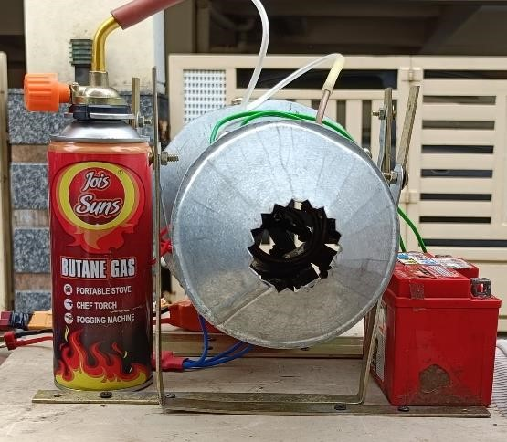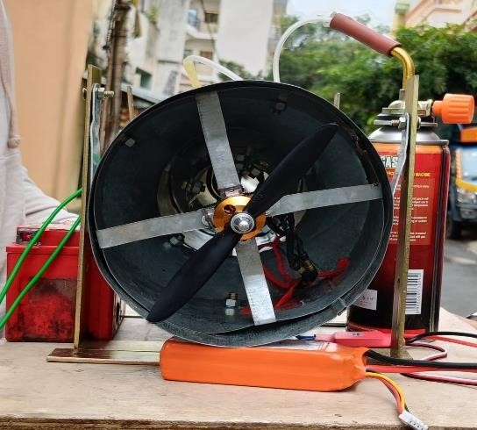

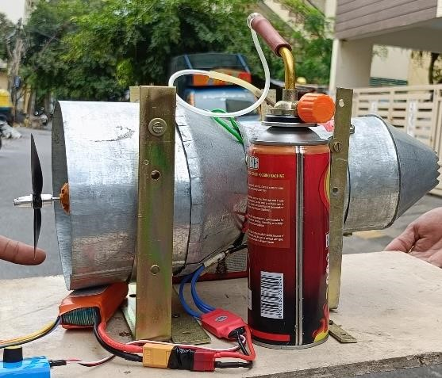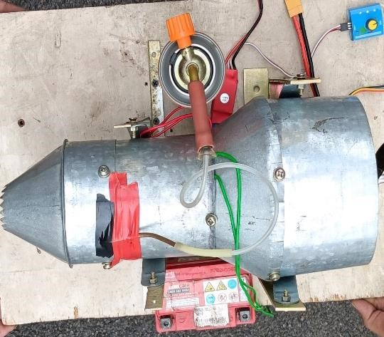

Figure 3.2: Model image.

### CHAPTER 4

#### 4.Advantages, Disadvantages and Applications

4.1. Advantages of Afterburner:

1. **Increased Thrust**: Afterburners significantly boost the thrust produced by a jet

Engine. By injecting additional fuel into the exhaust stream and igniting it, the engine

Can generate more power, which is particularly useful for supersonic speeds or

Combat situations.

**2.Improved Performance**: For military jets, afterburners are crucial for achieving the high speeds needed in combat or evasive maneuvers. They can also help in short takeoff and landing (STOL) operations where maximum thrust is needed.

**3.Enhanced Maneuverability**: In dogfighting and other high-performance scenarios, the extra thrust from afterburners can provide a temporary speed advantage and improve the aircraft's maneuverability.

4.Short-Term Efficiency: While afterburners are not fuel-efficient compared to standard engine operation, they provide a burst of power when needed without requiring a complete redesign of the engine.

**5.Reduced Weight**: By using afterburners, aircraft can achieve higher speeds without the need for larger, heavier engines or additional engines. This can contribute to better overall aircraft performance.

4.2. Disadvantages of Afterburner:

1. **Fuel Efficiency**: Afterburners are less fuel-efficient compared to other engine operation modes. The additional fuel burned in the afterburner contributes to increased fuel consumption, which can be problematic for long-duration flights or missions.
2. **Heat and Infrared Signature**: Afterburners generate significantly higher temperatures in the exhaust, which increases the aircraft's infrared signature. This makes the aircraft more detectable by heat-seeking missiles and other infrared tracking systems.
3. **Noise**: Afterburners produce a very high level of noise due to the rapid expansion and combustion of exhaust gases. This can make the aircraft more noticeable and can be a concern for operations near populated areas or in stealth missions.
4. **Engine Wear and Tear: The intense heat and high velocities involved in afterburner operation can accelerate engine wear and reduce the overall lifespan of the engine components. This can lead to higher maintenance costs and more frequent overhauls.**
5. **Limited Operational Time**: Because of the high fuel consumption and heat, afterburners are typically used only during specific phases of flight, such as takeoff, acceleration, or combat situations. They are not used continuously throughout a flight, limiting their operational time and effectiveness.
6. **Design Complexity and Weight**: Incorporating an afterburner into a jet engine adds complexity to the engine design. This can increase the weight of the engine and potentially affect the overall performance and aerodynamics of the aircraft.

4.3. Afterburner:

* 1. **Basic Jet Engine Operation**: In a typical jet engine, air is compressed, mixed with fuel, and then burned in the combustion chamber. The high-pressure, high-temperature exhaust gases are expelled through a nozzle, producing thrust.
  2. **Afterburner Addition**: An afterburner is an additional component attached to the rear of the engine's combustion chamber. It injects extra fuel into the exhaust stream after the combustion process has taken place.
  3. Ignition and Thrust Increase: The extra fuel is ignited in the afterburner, causing a further increase in temperature and volume of the exhaust gases. This additional combustion boosts the thrust without requiring a proportional increase in engine size or weight.
  4. **Exhaust Expansion**: The increased exhaust flow is directed through a larger nozzle, which further helps in producing additional thrust.

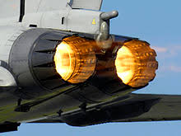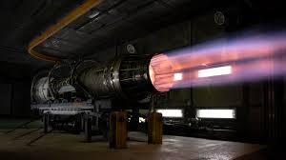

Afterburner in jet engines represent a promising technology for the future of space exploration, offering efficient and reliable propulsion solutions for a variety of mission profiles. Continued advancements in materials science, power management, and system integration are expected to enhance their capabilities and expand their application in the coming years.

### CHAPTER 5

#### 5.Results and Discussion

When discussing the results and implications of Afterburner, several key points emerge from their operational characteristics and performance metrics. Here’s a structured discussion on this topic:

5.1Results

5.1.1. Performance Metrics

1. Specific Impulse (Isp): - Electrochemical propulsion engines typically achieve higher specific impulse compared to traditional chemical rockets. This metric indicates the efficiency of the engine in converting propellant mass into thrust. Higher Isp values mean the engine can achieve greater velocity changes with less propellant, crucial for long-duration missions.
2. Thrust Generation: - While electrochemical engines generally provide lower thrust compared to chemical rockets, they excel in generating continuous thrust over extended periods. This steady thrust is beneficial for maintaining orbital position, performing delicate maneuvers, and conducting missions where precision is critical.
3. Power Efficiency: - Electrochemical engines require electrical power for operation, which can come from solar panels, nuclear sources, or batteries. Evaluating their power efficiency involves assessing how effectively the electrical energy is converted into thrust without significant losses.

5.1.2. Operational Considerations

1. Longevity and Reliability: - Electrochemical propulsion engines are known for their reliability and long operational lifetimes. Their design minimizes mechanical wear and potential failure points, contributing to extended mission durations without the need for refueling or significant maintenance.

2.Thermal Management: - Managing heat generated during electrochemical reactions is crucial. Excessive heat can degrade performance and potentially damage components. Effective thermal management systems ensure optimal operating temperatures are maintained throughout the engine’s operational cycle.

3. Propellant Efficiency: - The efficiency with which electrochemical engines utilize propellant is critical. Lower propellant consumption per unit of thrust extends mission duration and reduces overall mission costs by minimizing the need for resupply missions or refueling.

|  |  |
| --- | --- |
| Propeller | range |
| Low range rpm | 70 |
| Medium range rpm | 127 |
| High range rpm | 222 |
| Exhaust | speed |
| 40 | Km/hr. |
| Thrust generated using | load cell |
| Dry thrust | 9.81*1.62  16N |
| Wet thrust | 9.81*2.415  23.69N |

Table 5.1: Result calculation

5.2. Discussion Points

1. Advantages Over Chemical Propulsion: - Discuss how electrochemical engines compare favorably to chemical propulsion systems in terms of specific impulse, operational longevity, and efficiency. Highlight scenarios where electrochemical propulsion is preferable, such as deep space missions or satellite station keeping.
2. Applications and Future Prospects: - Explore current and potential future applications of electrochemical propulsion engines, including their role in small satellite deployment, interplanetary missions, and exploration of distant celestial bodies. Discuss ongoing research and development efforts to enhance their capabilities.
3. Challenges and Limitations: - Address challenges faced by electrochemical propulsion systems, such as their lower thrust compared to chemical rockets, dependence on reliable power sources, and complexity in design and manufacturing. Consider how these challenges are being addressed through technological advancements.
4. Environmental and Economic Impact: - Evaluate the environmental impact of electrochemical propulsion engines compared to traditional propulsion systems, particularly in terms of emissions and sustainability. Discuss economic factors such as operational costs and cost-effectiveness over the mission lifecycle.

### CHAPTER 6

#### 6.Conclusion & Future work

6.1. Conclusion

Electrochemical propulsion engines stand at the forefront of advanced space propulsion technologies, offering significant advantages and promising avenues for future exploration missions.

Electrochemical engines boast higher specific impulse compared to traditional chemical rockets, enabling efficient use of propellant and prolonged mission durations without the need for refueling. This efficiency is critical for deep space missions and satellite station keeping where precision and longevity are paramount.

These engines are renowned for their reliability and extended operational lifetimes. They minimize mechanical complexity and potential failure points, ensuring sustained performance over prolonged periods in the harsh conditions of space.

The ability to finely control thrust output allows for precise orbital maneuvers, attitude adjustments, and spacecraft rendezvous operations. This capability is essential for maintaining operational flexibility and achieving mission objectives with high accuracy.

Current applications range from geostationary satellite station keeping to deep space exploration missions. Ongoing advancements in electrode materials, power management systems, and thermal control are expanding the potential applications of electrochemical propulsion engines, including their integration into small satellite platforms (CubeSats).

Challenges such as lower thrust output compared to chemical rockets and the need for reliable power sources remain areas of focus for further development. Future directions include enhancing thrust efficiency, reducing operational costs, and integrating these engines with emerging space technologies such as autonomous navigation and in-situ resource utilization.

Electrochemical propulsion engines offer potential environmental benefits through reduced emissions compared to traditional chemical propulsion systems. Their economic viability is bolstered by their efficiency in propellant usage and potential for reducing overall mission costs over extended operational periods.

In essence, electrochemical propulsion engines represent a cornerstone of modern space propulsion technology, characterized by their efficiency, reliability, and adaptability to a wide range of space missions. As research and development continue to evolve, these engines are poised to play a pivotal role in advancing humanity’s exploration and utilization of space in the decades to come.

6.2. Future work

Now we can even increase the better efficiency in this engine by placing a single turbine which is placed after the combustion chamber and we can keep a thermally insulated generator inside the exhaust cone where we can even provide regening process too...!!

Looking ahead, the future of electrochemical propulsion engines holds promise for further innovation and application in space exploration. Research into new electrode materials that offer higher efficiency and stability over extended periods. Materials that can withstand harsh space environments and exhibit superior electrochemical performance are crucial.

Continued optimization of electrolyte compositions to improve ion conductivity and enhance overall engine efficiency. Development of more efficient and reliable power sources, such as advanced solar arrays, nuclear power systems, or high-energy-density batteries, to provide sustained electrical energy for propulsion.

Exploration of novel methods to increase thrust without compromising efficiency, potentially through optimized ion acceleration mechanisms or innovative nozzle designs. Advances in power management and distribution systems to ensure optimal energy utilization and minimize losses, thereby enhancing overall propulsion efficiency.

Further adaptation of electrochemical propulsion engines for CubeSats and small satellite platforms, enabling precise orbital maneuvers and extended mission capabilities. Development of compact and lightweight propulsion systems suitable for integration into smaller spacecraft without sacrificing performance or reliability. Integration of autonomous navigation and control systems to enhance operational autonomy and responsiveness of spacecraft equipped with electrochemical propulsion.

Exploration of ways to leverage electrochemical propulsion in conjunction with in-situ resource utilization technologies, such as utilizing lunar or Martian resources for propellant production.

Further reduction of environmental impacts through cleaner propulsion technologies and minimizing exhaust products that could affect space environments. Development of sustainable practices in manufacturing, operation, and disposal of propulsion systems to minimize the ecological footprint of space exploration.

Advancement of electrochemical propulsion systems to support ambitious interplanetary missions, including missions to Mars, outer planets, and beyond. Enhancing the reliability and longevity of electrochemical engines to support prolonged missions with minimal maintenance requirements.

The future of electrochemical propulsion engines is poised for significant advancements across multiple fronts, driven by ongoing research, technological innovation, and expanding applications in space exploration. Collaborative efforts between academia, industry, and space agencies will be essential in realizing these advancements and unlocking new possibilities for humanity's exploration and utilization of space.

Continued research and development in materials science, power management, and system integration are expected to further enhance the performance and versatility of electrochemical propulsion engines. These advancements will expand their applicability in future space missions, including manned exploration beyond Earth's orbit and sustainable space infrastructure development.

In summary, electrochemical propulsion engines represent a transformative technology in space propulsion, offering efficiency, precision, and sustainability crucial for the next generation of space exploration endeavors.

. References